Bug report for Avast

**Author:** Richard Tomek

**Platform:** Windows 10 Home, Android 7.0.

**Environment:** Google Chrome, Mozzila Firefox

**Assignment:**

# QA intern homework

**Manual testing task:**

**Task:** Create and present a structured bug report in English

**Web page for test:** https://www.avast.com/business/products/qa-intern-business-antivirus-pro-plus

**Test definition:** Please create a bug report that will be sorted and structured based on severity of the bugs found. You can use a text editor, tables or a professional tool (if you use one, please let us know which one). Do not test any other pages than the one mentioned above.

**Note:** In case of testing the cart always use the incognito window or delete cache before going back on the page to protect the integrity of the test results. The method you use to test this page is not important, neither are the tools you use for the testing. The important thing is that the results are logically structured and encompass all the important parts of the page and bugs found

|  |  |
| --- | --- |
| Bug ID | 13 |
| Title | Cart – pure HTML no appearance |
| Priority | High |
| Severity | Critical |
| Type | Functional |
| Platform | Windows 10 Home |
| Environment | Firefox Browser 73.0 (64-bit) – incognito mode |
| Source URL | <https://www.avast.com/business/products/qa-intern-business-antivirus-pro-plus> |
| Steps to reproduce | 1. Click on any buy button (does not matter how many devices or which Avast version) 2. Button takes you to cart 3. Page is in pure HTML, no styles etc. 4. Happened only in Firefox incognito mode |
| Expected result | Cart page |
| Actual result | Cart page without any graphical content (hard to use and navigate in) |
| Photos | See Below |

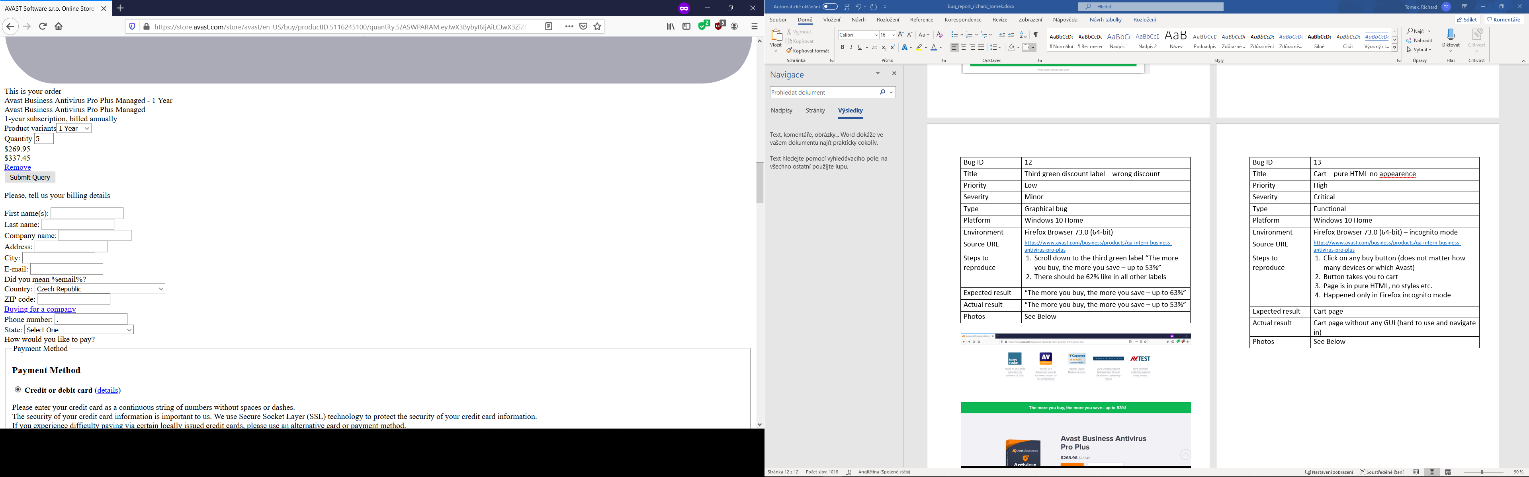

|  |  |
| --- | --- |
| Bug ID | 17 |
| Title | Additional random discount |
| Priority | High |
| Severity | Critical |
| Type | Functional |
| Platform | Windows 10 Home |
| Environment | Google Chrome 80.0.3987.106 64bit |
| Source URL | <https://www.avast.com/business/products/qa-intern-business-antivirus-pro-plus> |
| Steps to reproduce | 1. Go to the section where customer chooses count of devices to buy 2. Make the number of devices greater than 10 3. Move your mouse like you would like to close the browser 4. Pop up window with additional discount shows up 5. You’ll be taken to cart seeing the price with discount |
| Expected result | Cart with Antivirus Pro Plus for 5 devices with 10% additional discount |
| Actual result | Cart with Antivirus Pro Plus for your chosen number of devices with the discount |
| Photos | See on next page |

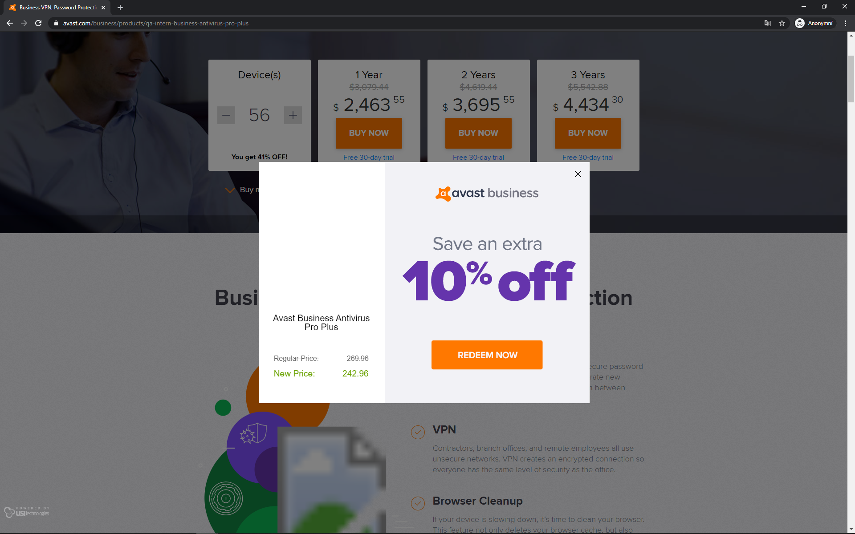

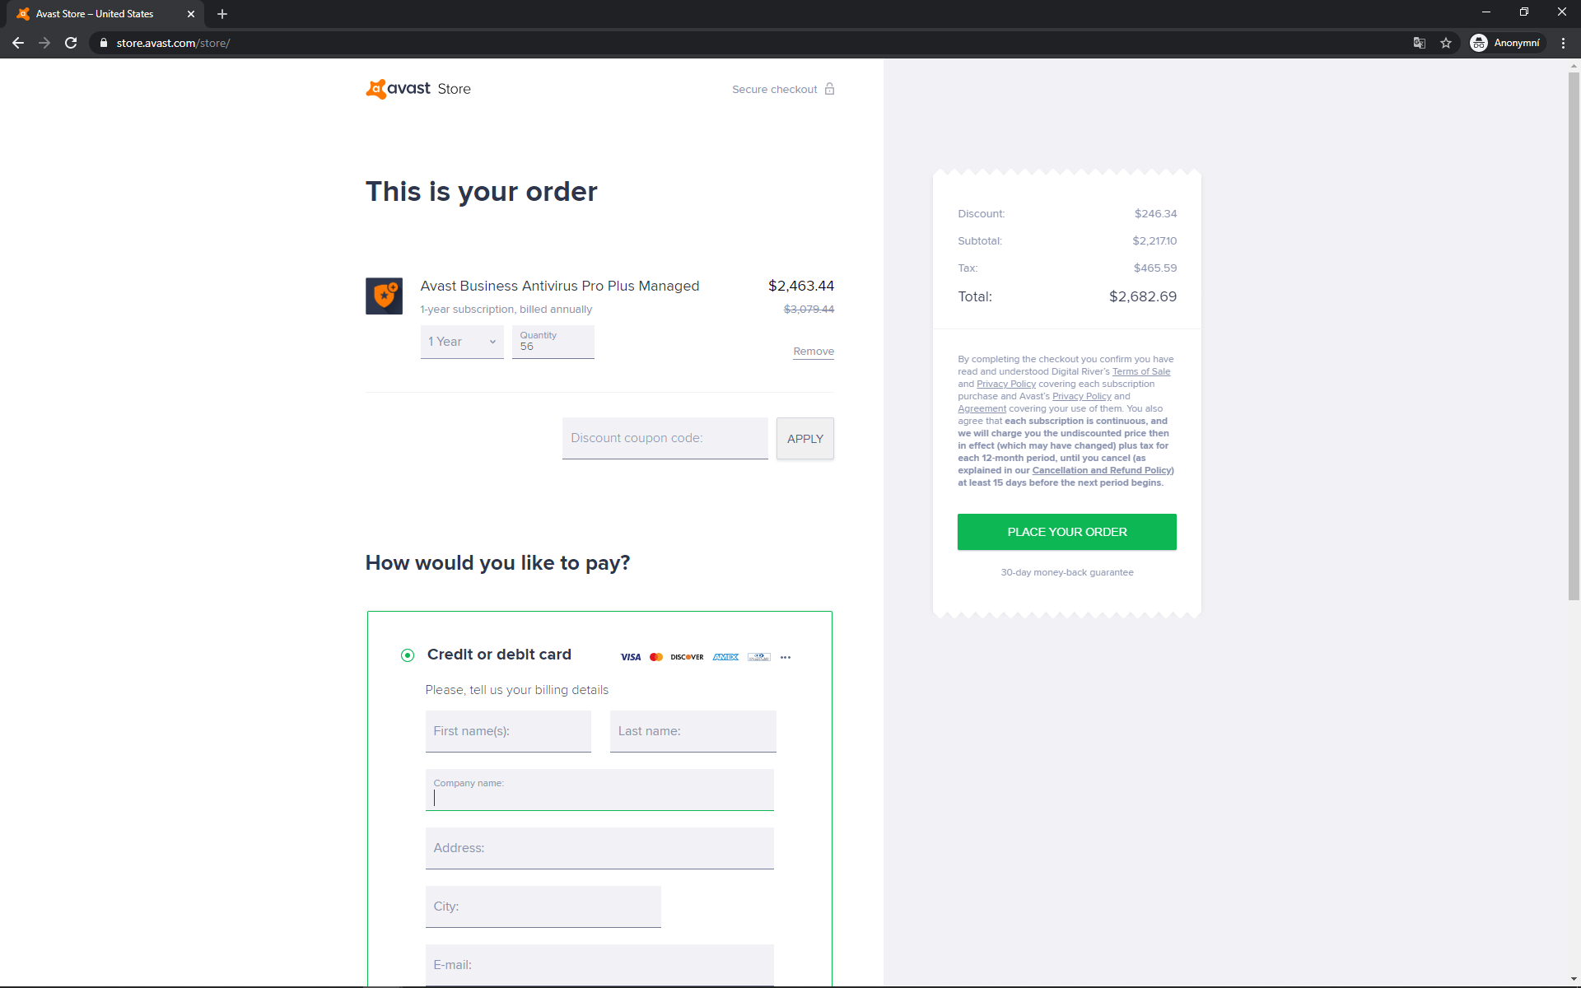

|  |  |
| --- | --- |
| Bug ID | 10 |
| Title | 20-49 devices 1 year – Discount 99% |
| Priority | High |
| Severity | Major |
| Type | Graphical bug |
| Platform | Windows 10 Home |
| Environment | Firefox Browser 73.0 (64-bit) |
| Source URL | <https://www.avast.com/business/products/qa-intern-business-antivirus-pro-plus> |
| Steps to reproduce | 1. Get to the section where customer chooses count of devices to buy 2. Choose between 20 - 49 devices 3. Shown discount is 99% 4. After clicking buy the price in the Cart is actually correct |
| Expected result | The discount should be between 28-41% |
| Actual result | The discount for 1 year is shown as 99% |
| Photos | See below |

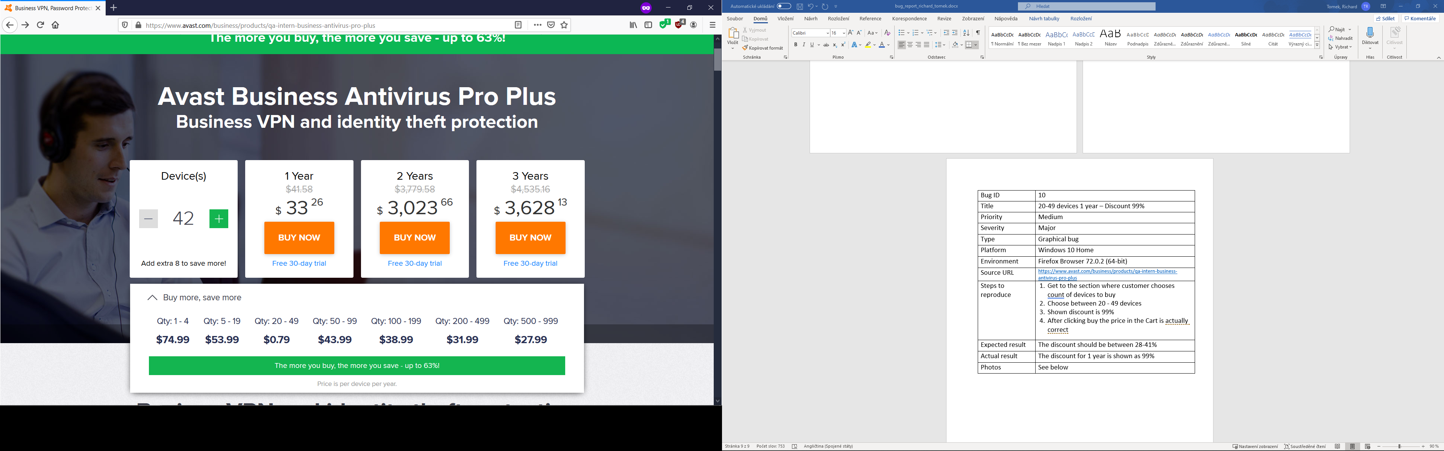

|  |  |
| --- | --- |
| Bug ID | 11 |
| Title | Cost – not calculated from shown prices |
| Priority | High |
| Severity | Major |
| Type | Graphical bug |
| Platform | Windows 10 Home |
| Environment | Firefox Browser 73.0 (64-bit) |
| Source URL | <https://www.avast.com/business/products/qa-intern-business-antivirus-pro-plus> |
| Steps to reproduce | 1. Get to the section where customer chooses count of devices to buy 2. Choose 950 devices 3. Shown final cost is wrong 4. After clicking buy, the price in the Cart is actually correct |
| Expected result | The final price should be 26590.5 in account of the price for one device in this quantity 27.99$ * 950 |
| Actual result | Shown final cost is 26592.4 |
| Photos | / |

|  |  |
| --- | --- |
| Bug ID | 8 |
| Title | Price – web price not matching cart price |
| Priority | High |
| Severity | Major |
| Type | Graphical bug |
| Platform | Windows 10 Home |
| Environment | Firefox Browser 73.0 (64-bit) |
| Source URL | <https://www.avast.com/business/products/qa-intern-business-antivirus-pro-plus> |
| Steps to reproduce | 1. Get to the section “Available Editions” 2. Click buy(any edition) 3. Shown price in cart has different decimals |
| Expected result | For Antivirus 174.96 |
| Actual result | 174.95 |
| Photos | / |

|  |  |
| --- | --- |
| Bug ID | 9 |
| Title | Wrong former price |
| Priority | Medium |
| Severity | Minor |
| Type | Graphical bug |
| Platform | Windows 10 Home |
| Environment | Firefox Browser 73.0 (64-bit) |
| Source URL | <https://www.avast.com/business/products/qa-intern-business-antivirus-pro-plus> |
| Steps to reproduce | 1. Get to the section where customer chooses count of devices to buy 2. Choose 5 devices 3. Look at the former price above the actual price with discount |
| Expected result | The former price should be 374,95 in account of the full price for 5 devices 74,99 * 5. |
| Actual result | The former price is 337,45 |
| Photos | / |

|  |  |
| --- | --- |
| Bug ID | 6 |
| Title | Fill amount of seats/devices with keyboard – numbers starting with 1 not working |
| Priority | Medium |
| Severity | Minor |
| Type | Functional |
| Platform | Windows 10 Home |
| Environment | Firefox Browser 73.0 (64-bit) |
| Source URL | <https://www.avast.com/business/products/qa-intern-business-antivirus-pro-plus> |
| Steps to reproduce | 1. Get to the section where customer chooses count of devices 2. Choose 2 devices with the + button 3. Mark the number(ctrl + A) 4. Type in 199 manually on keyboard |
| Expected result | User should see 199 devices chosen |
| Actual result | User sees number 99, 1 is overwritten by 9 |
| Photos | / |

|  |  |
| --- | --- |
| Bug ID | 18 |
| Title | Tired of clicking area – functions like button |
| Priority | Medium |
| Severity | Minor |
| Type | Functional |
| Platform | Windows 10 Home |
| Environment | Firefox Browser 73.0 (64-bit) |
| Source URL | <https://www.avast.com/business/products/qa-intern-business-antivirus-pro-plus> |
| Steps to reproduce | 1. Get to the section where customer chooses count of devices 2. Hover your mouse over the + or - button 3. Wait until message „Tired of clicking?“ comes up 4. Click on the message 5. It works like + button/-button |
| Note | There is no need to wait for the message to show up. Just hover over the button and click on the place where would the message show up. |
| Expected result | Nothing |
| Actual result | Message works like a button |
| Photos | / |

|  |  |
| --- | --- |
| Bug ID | 2 |
| Title | News and tips – page not found 404 |
| Priority | Low |
| Severity | Minor |
| Type | Functional |
| Platform | Windows 10 Home |
| Environment | Firefox Browser 73.0 (64-bit) |
| Source URL | <https://www.avast.com/business/products/qa-intern-business-antivirus-pro-plus> |
| Steps to reproduce | 1.Scroll down to “Get latest security news and tips” section  2. Click on the “Show more” button |
| Expected result | User should be taken to News and tips page |
| Actual result | Page not found Error 404 |
| Photos | / |

|  |  |
| --- | --- |
| Bug ID | 1 |
| Title | See all features - button not working |
| Priority | Low |
| Severity | Minor |
| Type | Functional |
| Platform | Windows 10 Home |
| Environment | Firefox Browser 73.0 (64-bit) |
| Source URL | <https://www.avast.com/business/products/qa-intern-business-antivirus-pro-plus> |
| Steps to reproduce | 1. Scroll down to “Business VPN and identity theft protection” section  2. Click on the “See all features button” – at the bottom of the section |
| Expected result | Should take user to another page or open features table |
| Actual result | Does nothing |
| Photos | / |

|  |  |
| --- | --- |
| Bug ID | 3 |
| Title | Visible source code |
| Priority | Low |
| Severity | Minor |
| Type | Graphical bug |
| Platform | Windows 10 Home |
| Environment | Firefox Browser 73.0 (64-bit) |
| Source URL | <https://www.avast.com/business/products/qa-intern-business-antivirus-pro-plus> |
| Steps to reproduce | 1.Scroll down to the bottom of the page |
| Expected result | Source code should not be visible |
| Actual result | User can see source code |
| Photos | See below |

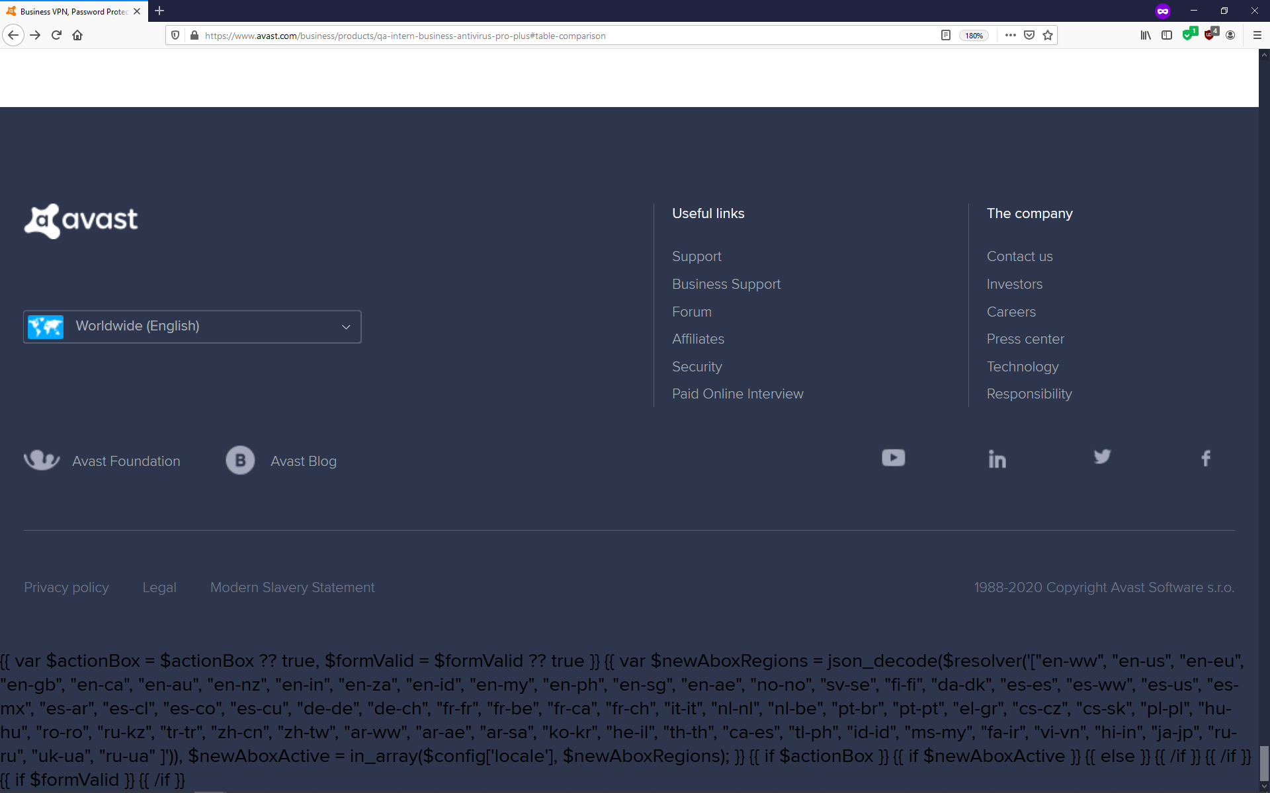

|  |  |
| --- | --- |
| Bug ID | 4 |
| Title | Links images not showing |
| Priority | Low |
| Severity | Minor |
| Type | Graphical bug |
| Platform | Windows 10 Home |
| Environment | Firefox Browser 73.0 (64-bit) |
| Source URL | <https://www.avast.com/business/products/qa-intern-business-antivirus-pro-plus> |
| Steps to reproduce | 1.Scroll down to “Get latest security news and tips” section  2. Three small articles have blank space for image which is not loading properly |
| Expected result | User should see an image with an article |
| Actual result | User can only see article without image |
| Photos | See below |

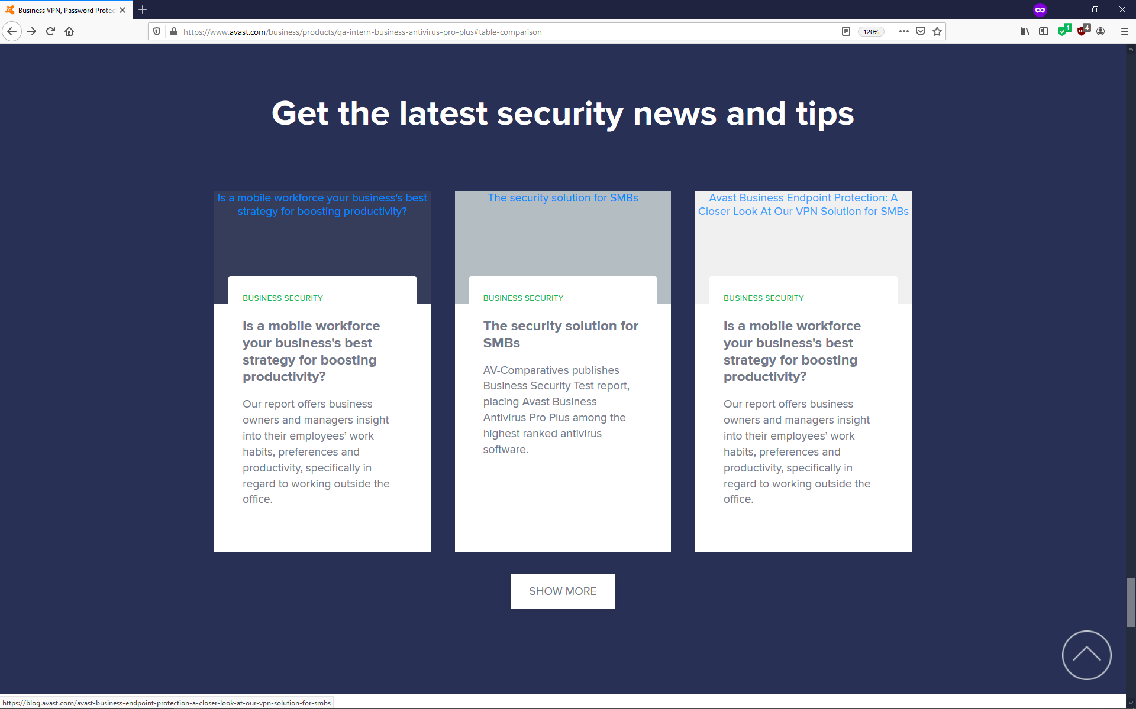

|  |  |
| --- | --- |
| Bug ID | 12 |
| Title | Third green discount label – wrong discount |
| Priority | Low |
| Severity | Minor |
| Type | Graphical bug |
| Platform | Windows 10 Home |
| Environment | Firefox Browser 73.0 (64-bit) |
| Source URL | <https://www.avast.com/business/products/qa-intern-business-antivirus-pro-plus> |
| Steps to reproduce | 1. Scroll down to the third green label “The more you buy, the more you save – up to 53%” 2. There should be 62% like in all other labels |
| Expected result | “The more you buy, the more you save – up to 63%” |
| Actual result | “The more you buy, the more you save – up to 53%” |
| Photos | See Below |

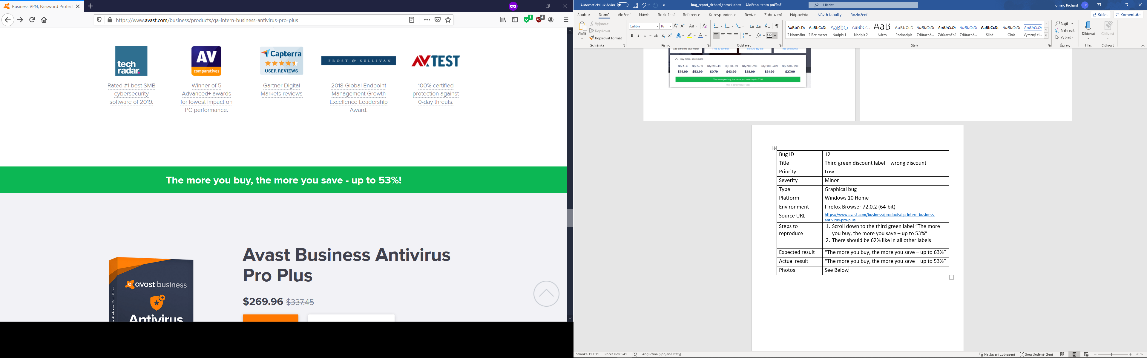

|  |  |
| --- | --- |
| Bug ID | 15 |
| Title | Features – broken image |
| Priority | Low |
| Severity | Minor |
| Type | Graphical bug |
| Platform | Windows 10 Home |
| Environment | Google Chrome 80.0.3987.106 64bit |
| Source URL | <https://www.avast.com/business/products/qa-intern-business-antivirus-pro-plus> |
| Steps to reproduce | 1. Scroll down to the Business VPN and identity theft protection feature section 2. You should see a broken image |
| Expected result | Graphical part/image |
| Actual result | Icon of a broken image |
| Photos | See Below |

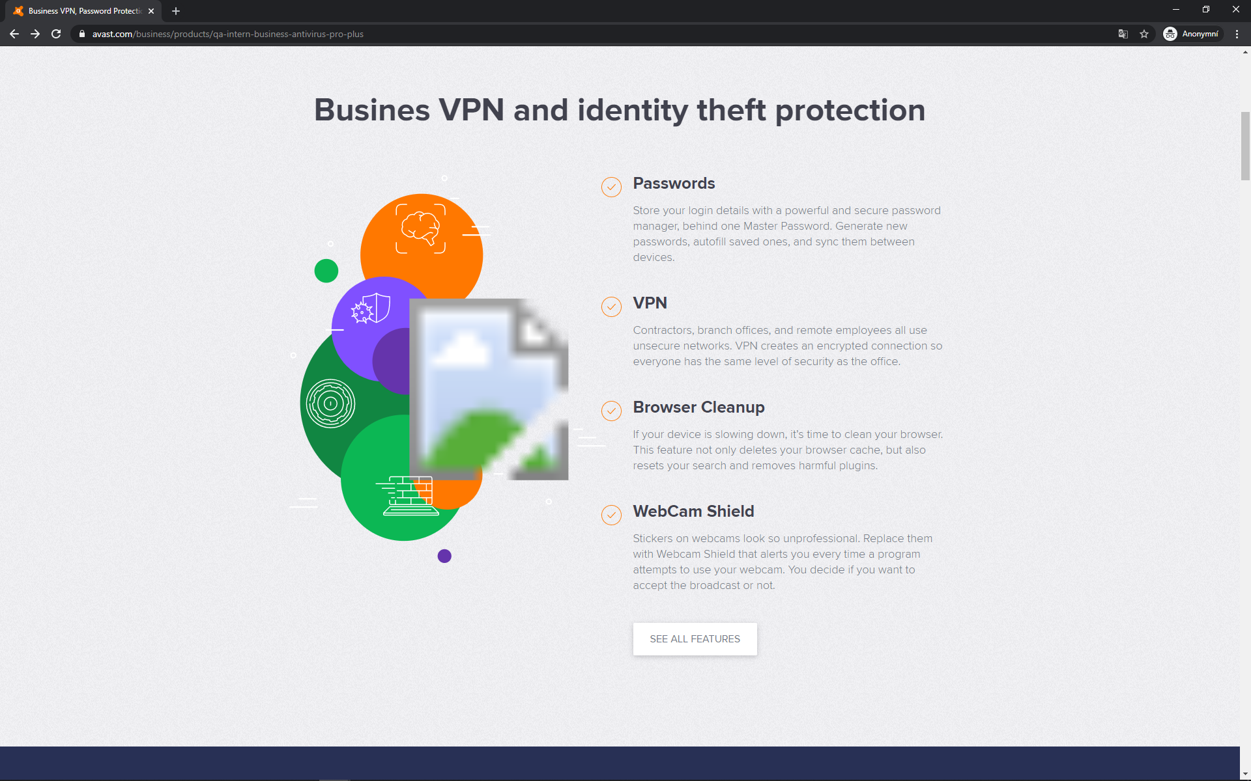

|  |  |
| --- | --- |
| Bug ID | 15 |
| Title | Features – broken image |
| Priority | Low |
| Severity | Minor |
| Type | Graphical bug |
| Platform | Windows 10 Home |
| Environment | Google Chrome 80.0.3987.106 64bit |
| Source URL | <https://www.avast.com/business/products/qa-intern-business-antivirus-pro-plus> |
| Steps to reproduce | 1. Scroll down to the Business VPN and identity theft protection feature section 2. You should see a broken image |
| Expected result | Graphical part/image |
| Actual result | Icon of a broken image |
| Photos | See Below |

|  |  |
| --- | --- |
| Bug ID | 16 |
| Title | Phone/web zoom |
| Priority | Low |
| Severity | Minor |
| Type | Graphical bug |
| Platform | Android 7.0/Windows 10 Home |
| Environment | Google Chrome 79.0.3945.136  Google Chrome 80.0.3987.106 64bit |
| Source URL | <https://www.avast.com/business/products/qa-intern-business-antivirus-pro-plus> |
| Steps to reproduce | 1. On Phone 2. Open the website on your phone 3. Try to scroll horizontally 4. On Pc 5. Open the website on your pc 6. Zoom in as much as you can 7. Try to scroll horizontally |
| Expected result | No horizontal scrolling without content |
| Actual result | Ability to scroll right and see background |
| Photos | See Below |

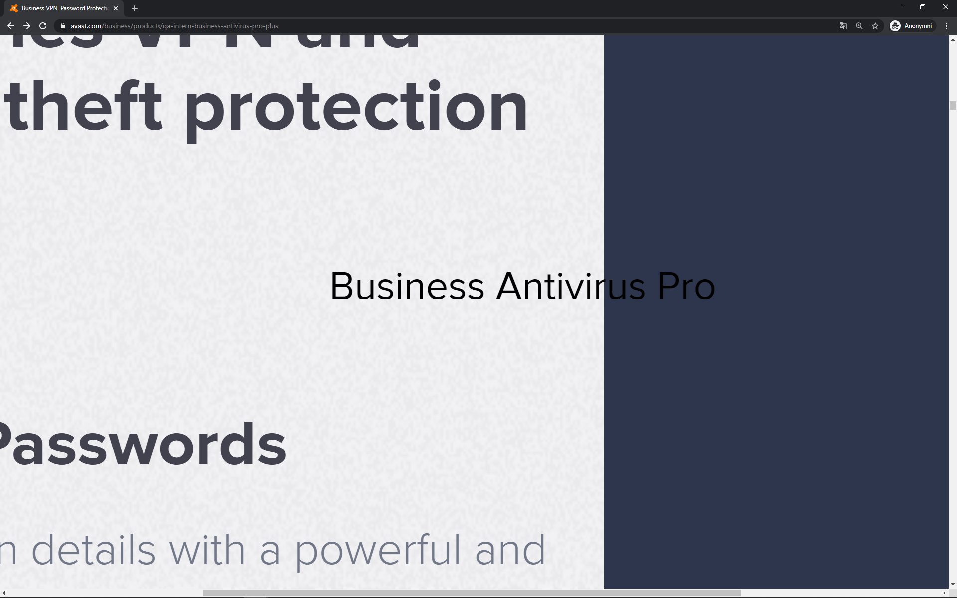

|  |  |
| --- | --- |
| Bug ID | 19 |
| Title | Additional discount pop up – missing image |
| Priority | Low |
| Severity | Minor |
| Type | Graphical bug |
| Platform | Windows 10 Home |
| Environment | Google Chrome 80.0.3987.106 64bit |
| Source URL | <https://www.avast.com/business/products/qa-intern-business-antivirus-pro-plus> |
| Steps to reproduce | 1. Go to the section where customer chooses count of devices to buy 2. Make the number of devices greater than 10 3. Move your mouse like you would like to close the browser 4. Pop up window with additional discount shows up 5. The window has large white space where an image is missing |
| Expected result | Image of the reduced product |
| Actual result | White space/no image just price |
| Photos | See below |



|  |  |
| --- | --- |
| Bug ID | 14 |
| Title | Subtitle – typing error |
| Priority | Low |
| Severity | Minor |
| Type | Wording bug |
| Platform | Windows 10 Home |
| Environment | Firefox Browser 73.0 (64-bit) |
| Source URL | <https://www.avast.com/business/products/qa-intern-business-antivirus-pro-plus> |
| Steps to reproduce | 1. Scroll down to the Business VPN and identity theft protection feature section 2. Title of the section is missing “s” in “Busines” |
| Expected result | “Business VPN and identity theft protection” |
| Actual result | “Busines VPN and identity theft protection” |
| Photos | / |

|  |  |
| --- | --- |
| Bug ID | 5 |
| Title | Discount suggestion – not fitting in the box |
| Priority | Low |
| Severity | Suggestion |
| Type | Graphical bug |
| Platform | Windows 10 Home |
| Environment | Firefox Browser 73.0 (64-bit) |
| Source URL | <https://www.avast.com/business/products/qa-intern-business-antivirus-pro-plus> |
| Steps to reproduce | 1.Get to the section where customer chooses count of devices  2. Choose 180 devices  3. Add 1 more device  4. Observe the change in the shown advice telling you how far are you from next discount |
| Expected result | User should see suggestion on one line |
| Actual result | Suggestion with 20 devices is on 2 lines against 19 devices which are on one line |
| Photos | See below |

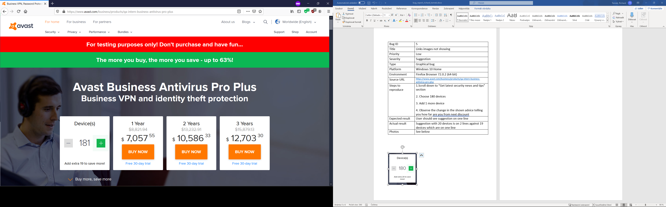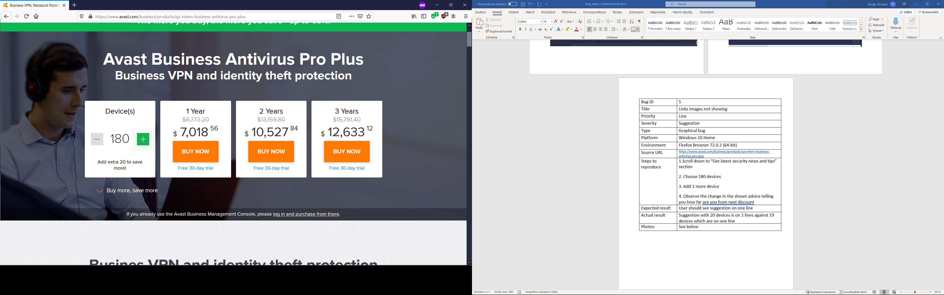

|  |  |
| --- | --- |
| Bug ID | 7 |
| Title | Prices for (1,2,3) years – Discount for (2,3) years not shown in percent (Maybe on purpose) |
| Priority | Low |
| Severity | Suggestion |
| Type | Graphical bug |
| Platform | Windows 10 Home |
| Environment | Firefox Browser 73.0 (64-bit) |
| Source URL | <https://www.avast.com/business/products/qa-intern-business-antivirus-pro-plus> |
| Steps to reproduce | 1. Get to the section where customer chooses count of devices to buy |
| Expected result | User could see how much he can save in percent by choosing more than 1 year |
| Actual result | User sees only the difference in price |
| Photos | / |